Practical 1: Pairwise meta-analysis and indirect comparisons

Course on network meta-analysis, Kea, Greece

## R packages

We will use the package **readxl** to import excel data and the package **meta** to run subgroup meta-analyses and meta-regression.

library(readxl)  
library(meta)

Note, package **metafor** is called internally for meta-regression and must be available.

Results (treatment estimates and confidence intervals) should be rounded to two digits (default is four digits).

settings.meta(digits = 2)

## Pairwise meta-analysis

### Acute mania dataset

Open the dataset AcuteManiaP.xls by using the *Import Dataset* tab or type

AcuteManiaP = read_excel("AcuteManiaP.xls")  
AcuteManiaP = as.data.frame(AcuteManiaP)

This dataset includes studies comparing Placebo with active antimanic drugs. Check the data structure:

str(AcuteManiaP)

## 'data.frame': 27 obs. of 15 variables:  
## $ studlab: num 51 53 54 56 58 67 50 52 61 62 ...  
## $ treat1 : chr "Placebo" "Placebo" "Placebo" "Placebo" ...  
## $ treat2 : chr "Haloperidol" "Haloperidol" "Haloperidol" "Haloperidol" ...  
## $ ncont1 : num 152 100 88 47 138 97 163 95 NA 95 ...  
## $ mean1 : num 18.6 24.2 -6.1 -8.2 22.1 ...  
## $ sd1 : num 10.6 12.4 10.7 10 10.2 ...  
## $ ncont2 : num 161 98 170 50 144 20 155 98 NA 36 ...  
## $ mean2 : num 14.7 15.9 -15.9 -13.4 17.4 ...  
## $ sd2 : num 10.6 12.4 10.7 10 10.2 ...  
## $ event1 : num 58 35 18 NA 39 43 56 26 18 NA ...  
## $ n1 : num 153 101 88 51 140 99 165 97 74 95 ...  
## $ event2 : num 80 55 93 NA 59 13 71 52 18 NA ...  
## $ n2 : num 165 99 172 53 144 20 160 98 36 36 ...  
## $ AE1 : num 2 0 0 1 3 0 5 1 0 2 ...  
## $ AE2 : num 5 2 2 1 5 1 2 5 1 0 ...

## Meta-analysis for a continuous outcome

The outcome efficacy can be measured using a symptoms scale (mean, sd and ncont for arms 1 and 2). The lower the outcome, the better the efficacy of the treatment. The treatments for arms 1 and 2 can be seen in variables t1, t2. Some studies report endpoint values but most studies report change from baseline. Because studies might use different scales to measure the outcome, we will synthesize the data using the standardized mean difference (SMD).

### Meta-analyses and estimation of heterogeneity

Summarize the SMDs from studies using metacont. We will create an object of class meta called "pooledSMD1" Then the pooled SMD is obtained as:

pooledSMD1 = metacont(ncont1, mean1, sd1, ncont2, mean2, sd2,  
 data = AcuteManiaP, studlab = studlab, sm = "SMD")  
summary(pooledSMD1)

## Number of studies combined: k = 26  
##   
## SMD 95%-CI z p-value  
## Fixed effect model 0.49 [0.44; 0.55] 17.71 < 0.0001  
## Random effects model 0.49 [0.42; 0.57] 12.64 < 0.0001  
##   
## Quantifying heterogeneity:  
## tau^2 = 0.0176; H = 1.37 [1.09; 1.72]; I^2 = 46.4% [15.2%; 66.2%]  
##   
## Test of heterogeneity:  
## Q d.f. p-value  
## 46.68 25 0.0054  
##   
## Details on meta-analytical method:  
## - Inverse variance method  
## - DerSimonian-Laird estimator for tau^2  
## - Hedges' g (bias corrected standardised mean difference)

This estimates the summary effect (SMD) using both the random and the fixed effects model. Compare the results between the random and fixed effect and comment on the magnitude of heterogeneity (consider I2 and tau2). How was heterogeneity estimated?

Let us meta-analyse only the studies that compare Placebo and Risperidone. We will create an object called pooledSMD2; let us estimate random effects only.

pooledSMD2 = update(pooledSMD1, subset = treat2 == "Risperidone", comb.fixed = FALSE)  
summary(pooledSMD2)

## Number of studies combined: k = 5  
##   
## SMD 95%-CI z p-value  
## Random effects model 0.59 [0.43; 0.76] 7.01 < 0.0001  
##   
## Quantifying heterogeneity:  
## tau^2 = 0.0149; H = 1.31 [1.00; 2.17]; I^2 = 42.1% [0.0%; 78.7%]  
##   
## Test of heterogeneity:  
## Q d.f. p-value  
## 6.91 4 0.1405  
##   
## Details on meta-analytical method:  
## - Inverse variance method  
## - DerSimonian-Laird estimator for tau^2  
## - Hedges' g (bias corrected standardised mean difference)

How many studies are included now? How much is the heterogeneity? Comment on the confidence intervals of I2.

### Create forest plots

To obtain a forest plot we will use the command forest. Sort the studies from the smallest to the largest.

forest(pooledSMD2, sortvar = n1 + n2)

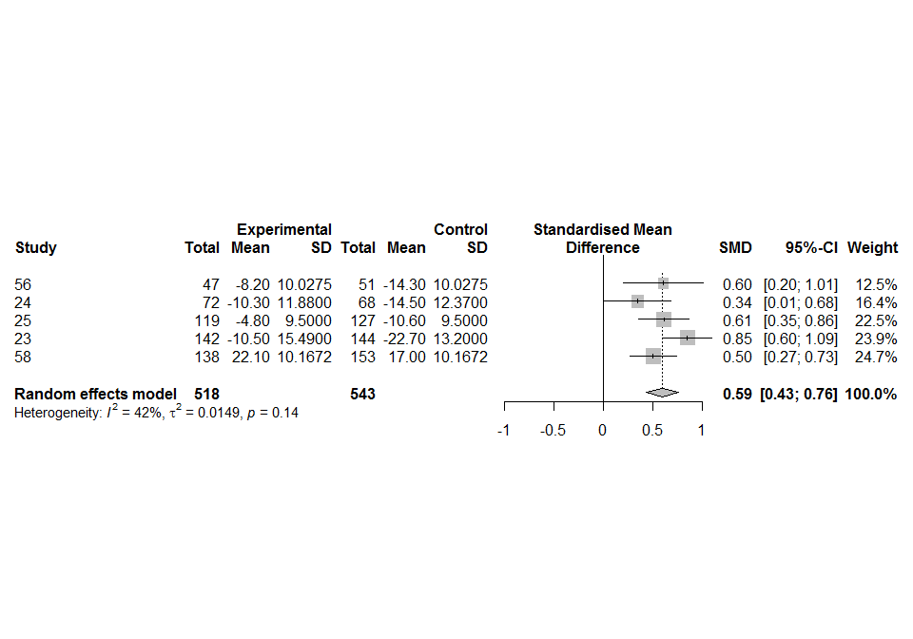

Compare the % weight attributed to the largest and smallest study between random and fixed effect model. Do larger studies produce treatment effects that are different to those oberved in smaller studies?

To obtain prediction intervals on the summary effect you need to add the option prediction=T.

forest(pooledSMD2, sortvar = ncont1 + ncont2,  
 prediction = TRUE, comb.fixed = FALSE)

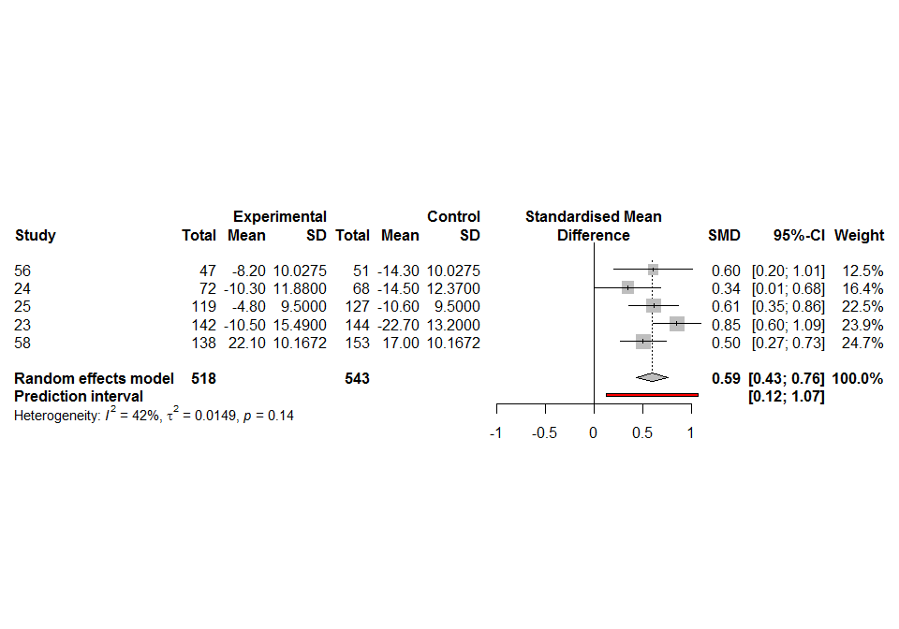

What do these prediction intervals mean?

## Meta-analysis for a dichotomous outcome

The dataset includes a dichotomous efficacy outcome, measured using the number of responders (event1 and event2) out of the total patients randomised (n1 and n2). The larger the percentage of responders, the better the efficacy of the treatment. There are also two columns, called AE1 and AE2; these have the number of serious adverse events in each arm.

### Meta-analysis of efficacy

Summarize the study-specific odds ratios for efficacy (response) from studies using metabin. We will create an object of class meta called "pooledOR"

pooledOR = metabin(event2, n2, event1, n1,  
 data = AcuteManiaP, studlab = studlab, sm = "OR")  
summary(pooledOR)

## Number of studies combined: k = 20  
##   
## OR 95%-CI z p-value  
## Fixed effect model 2.15 [1.89; 2.43] 12.00 < 0.0001  
## Random effects model 2.16 [1.81; 2.59] 8.41 < 0.0001  
##   
## Quantifying heterogeneity:  
## tau^2 = 0.0793; H = 1.40 [1.08; 1.81]; I^2 = 48.8% [14.1%; 69.5%]  
##   
## Test of heterogeneity:  
## Q d.f. p-value  
## 37.14 19 0.0076  
##   
## Details on meta-analytical method:  
## - Mantel-Haenszel method  
## - DerSimonian-Laird estimator for tau^2

Which method was used to estimate the odds-ratio? How was heterogeneity estimated?

To obtain the forest plot, we will use again the forest function (and play a little with the colours and fonts)

forest(pooledOR, sortvar = n1 + n2 , layout = "JAMA", allstudies = F,  
 fs.study = 10, ff.study = "italic",  
 col.diamond = "green", col.diamond.lines = "red",  
 col.square = "yellow", col.square.lines = "blue")

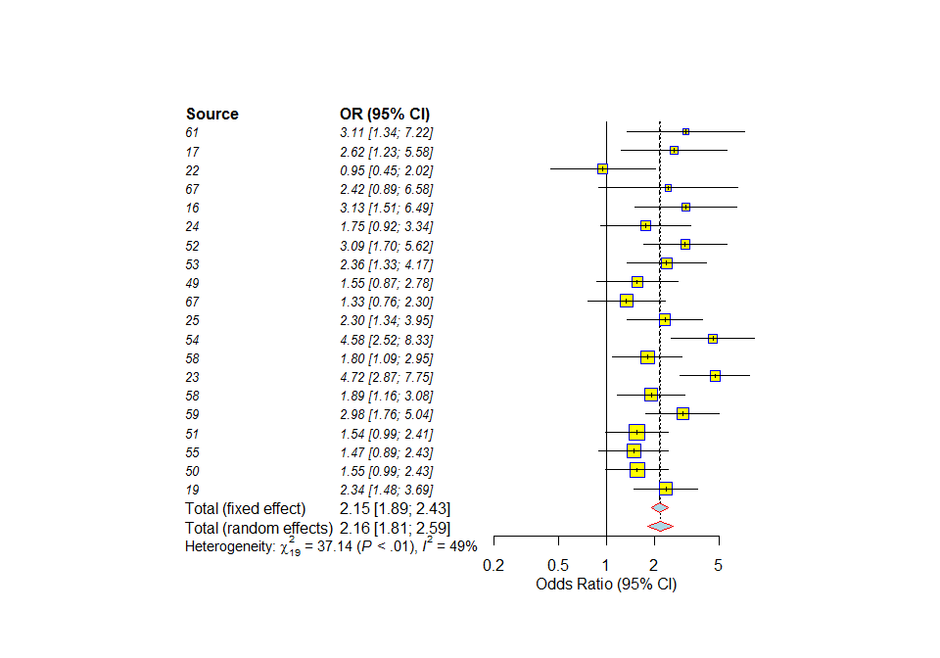

## Subgroup analysis and meta-regression

### Acute mania secondary efficacy outcome dataset

The file AcuteMania.xls comprises data from the secondary efficacy outcome of the network meta-analysis published in Cipriani et al. (2011). Read in the file and create a new dataset *mania.op* only containing information from pairwise comparisons of Olanzapine ("OLA") and Placebo ("PLA").

AcuteMania = read_excel("AcuteMania.xls")  
AcuteMania = as.data.frame(AcuteMania)  
# Select studies with treatments "OLA" and "PLA"  
mania.o = AcuteMania[AcuteMania$treatment == "OLA", ]  
mania.p = AcuteMania[AcuteMania$treatment == "PLA", ]  
# Drop unnecessary variables  
mania.o$treatment = mania.o$rob = mania.p$treatment = NULL  
# Merge datasets  
mania.op = merge(mania.o, mania.p, by = "studyid", suffixes = c(".ola", ".pla"))  
# Risk of bias assessment (1 = low risk, 2 = moderate risk)  
mania.op$rob = factor(mania.op$rob, levels = 1:2, labels = c("low", "moderate"))

The list of variables (data structure) can be printed using the following command:

str(mania.op)

## 'data.frame': 8 obs. of 6 variables:  
## $ studyid: num 14 15 17 19 36 42 44 47  
## $ r.ola : num 34 35 149 37 40 82 94 53  
## $ n.ola : num 70 55 229 58 101 215 190 105  
## $ r.pla : num 16 24 51 39 30 31 26 43  
## $ n.pla : num 69 60 115 60 101 105 105 99  
## $ rob : Factor w/ 2 levels "low","moderate": 2 1 2 1 2 1 2 2

The variables have the following meaning:

|  |  |
| --- | --- |
| Variable | Description |
| studyid | Study number |
| r.ola | Number of responders in Olanzapine group |
| n.ola | Number of patients in Olanzapine group |
| r.pla | Number of responders in Placebo group |
| n.pla | Number of patients in Placebo group |
| rob | Risk of bias assessment |

### Schizophrenia dataset

The file Leucht.xls comprises data from the primary outcome (efficacy) of the systematic review and network meta-analysis published in Leucht et al. (2013).

Leucht = read_excel("Leucht.xls")  
Leucht = as.data.frame(Leucht)

The list of variables (data structure) can be printed using the following command.

str(Leucht)

## 'data.frame': 247 obs. of 7 variables:  
## $ year : num 1969 1970 1970 1971 1972 ...  
## $ id : num 196 39 40 41 42 168 168 168 70 115 ...  
## $ study : num 196 39 40 41 42 168 168 168 70 115 ...  
## $ treat1: chr "CPZ" "CPZ" "CPZ" "CPZ" ...  
## $ treat2: chr "PBO" "PBO" "PBO" "PBO" ...  
## $ effect: num -0.284 -0.873 -0.565 -0.514 -0.18 ...  
## $ se : num 0.367 0.398 0.351 0.331 0.349 ...

The variables have the following meaning:

|  |  |
| --- | --- |
| Variable | Description |
| year | Year of publication |
| id | Study number |
| study | Study number |
| treat1 | First treatment |
| treat2 | Second treatment |
| effect | Standardized mean difference (efficacy, small values are good) |
| se | Standard error of effect |

Generate a dataset *leucht.cp* containing only pairwise comparisons of Clozapine ("CPZ") and Placebo ("PBO"). Furthermore, generate a new variable 'year.1990' which centers the publication year around the year 1990.

leucht.cp = Leucht[Leucht$treat1 == "CPZ" & Leucht$treat2 == "PBO", ]  
leucht.cp$year.1990 = leucht.cp$year - 1990  
leucht.cp$year.1990

## [1] -21 -20 -20 -19 -18 -18 -13 -6 0 1 10

## Subgroup analysis

For the acute mania dataset, perform a meta-analysis to compare the response probabilities using the inverse-variance method (argument method="Inverse"); create a new R object *m1*. Comment on the heterogeneity.

m1 = metabin(r.ola, n.ola, r.pla, n.pla, data = mania.op,  
 studlab = studyid, sm = "OR", method = "Inverse")  
summary(m1)

## Number of studies combined: k = 8  
##   
## OR 95%-CI z p-value  
## Fixed effect model 1.91 [1.56; 2.34] 6.20 < 0.0001  
## Random effects model 1.90 [1.44; 2.50] 4.53 < 0.0001  
##   
## Quantifying heterogeneity:  
## tau^2 = 0.0684; H = 1.33 [1.00; 2.00]; I^2 = 43.6% [0.0%; 75.1%]  
##   
## Test of heterogeneity:  
## Q d.f. p-value  
## 12.42 7 0.0877  
##   
## Details on meta-analytical method:  
## - Inverse variance method  
## - DerSimonian-Laird estimator for tau^2

Very similar treatment estimates in fixed effect and random effects model showing a highly statistical significant result. However, the results show evidence of heterogeneity at the 10% level (p=0.0877) which warrants the conduct of subgroup analyses.

Now investigate a possible difference by risk of bias status by re-running your meta-analysis with subgroups (argument byvar); create a new R object *m1.rob*.

# New function call:  
m1.rob = metabin(r.ola, n.ola, r.pla, n.pla, data = mania.op, studlab = studyid,  
 sm = "OR", method = "Inverse", byvar = rob)  
# Same result using R function update.meta():  
m1.rob = update(m1, byvar = rob)  
summary(m1.rob)

## Number of studies combined: k = 8  
##   
## OR 95%-CI z p-value  
## Fixed effect model 1.91 [1.56; 2.34] 6.20 < 0.0001  
## Random effects model 1.90 [1.44; 2.50] 4.53 < 0.0001  
##   
## Quantifying heterogeneity:  
## tau^2 = 0.0684; H = 1.33 [1.00; 2.00]; I^2 = 43.6% [0.0%; 75.1%]  
##   
## Test of heterogeneity:  
## Q d.f. p-value  
## 12.42 7 0.0877  
##   
## Results for subgroups (fixed effect model):  
## k OR 95%-CI Q tau^2 I^2  
## rob = low 3 1.52 [1.06; 2.19] 3.53 0.0876 43.4%  
## rob = moderate 5 2.12 [1.65; 2.71] 6.72 0.0548 40.5%  
##   
## Test for subgroup differences (fixed effect model):  
## Q d.f. p-value  
## Between groups 2.16 1 0.1417  
## Within groups 10.26 6 0.1143  
##   
## Results for subgroups (random effects model):  
## k OR 95%-CI Q tau^2 I^2  
## rob = low 3 1.53 [0.92; 2.54] 3.53 0.0876 43.4%  
## rob = moderate 5 2.11 [1.53; 2.92] 6.72 0.0548 40.5%  
##   
## Test for subgroup differences (random effects model):  
## Q d.f. p-value  
## Between groups 1.11 1 0.2917  
##   
## Details on meta-analytical method:  
## - Inverse variance method  
## - DerSimonian-Laird estimator for tau^2

Looking first at the fixed effect analysis, how does the decomposition of Q work?

We see that the total heterogeneity statistic is *Q*=12.42, with 8-1=7 degrees of freedom, and this is decomposed into 3.53 (within low risk group), 6.72 (within moderate risk group), and 2.16 (between subgroups). Summing the heterogeneity statistics gives 3.53+6.72+2.16=12.42, i.e., the value of the total heterogeneity statistic.

Looking at the results in the two subgroups (random effects model), what do you conclude? Does risk of bias explain the heterogeneity in treatment effects?

We see that the effect appears slightly stronger in the moderate risk subgroup. However the difference between studies with low and moderate risk of bias is not significant at the 10% level (test for subgroup differences: p=0.2917). In summary, risk of bias does not explain the statistical heterogeneity observed in the study results.

Redo the random effects subgroup meta-analysis assuming a common value for $τ^{2}$ (argument tau.common=TRUE); create a new R object *m1.rob.c*.

m1.rob.c = update(m1.rob, tau.common = TRUE, comb.fixed = FALSE)  
summary(m1.rob.c)

## Number of studies combined: k = 8  
##   
## OR 95%-CI z p-value  
## Random effects model 1.90 [1.44; 2.50] 4.53 < 0.0001  
##   
## Quantifying heterogeneity:  
## tau^2 = 0.0684; H = 1.33 [1.00; 2.00]; I^2 = 43.6% [0.0%; 75.1%]  
##   
## Test of heterogeneity:  
## Q d.f. p-value  
## 12.42 7 0.0877  
##   
## Results for subgroups (random effects model):  
## k OR 95%-CI Q tau^2 I^2  
## rob = low 3 1.53 [0.95; 2.45] 3.53 0.0634 43.4%  
## rob = moderate 5 2.12 [1.51; 2.95] 6.72 0.0634 40.5%  
##   
## Test for subgroup differences (random effects model):  
## Q d.f. p-value  
## Between groups 1.21 1 0.2718  
## Within groups 10.26 6 0.1143  
##   
## Details on meta-analytical method:  
## - Inverse variance method  
## - DerSimonian-Laird estimator for tau^2 (assuming common tau^2 in subgroups)

Overall, the results do not change much assuming a common between-study variance.

## Meta-regression with a binary covariate

Conduct a meta-regression for R object *m1.rob* (or *m1*) and compare the results with the subgroup analysis assuming a common value for $τ^{2}$ (*m1.rob.c*). Look at the results of *Test of Moderators* in the meta-regression and the *Test for subgroup differences* in the random effects subgroup meta-analysis. Furthermore, compare treatment estimates in the two subgroups. Note, (i) coefficients can be extracted using R function coef() and (ii) results for the meta-regression are reported on the log-scale (use of exp() necessary for back-transformation).

As R object *m1.rob* was generated using argument byvar, we do not have to specify a covariate in the meta-regression command.

mr1.rob = metareg(m1.rob)

We get the same result explicitly stating the covariate 'rob' using *m1* (or *m1.rob*).

mr1.rob = metareg(m1, rob)

Result of the meta-regression:

mr1.rob

##   
## Mixed-Effects Model (k = 8; tau^2 estimator: DL)  
##   
## tau^2 (estimated amount of residual heterogeneity): 0.0634 (SE = 0.0889)  
## tau (square root of estimated tau^2 value): 0.2518  
## I^2 (residual heterogeneity / unaccounted variability): 41.50%  
## H^2 (unaccounted variability / sampling variability): 1.71  
## R^2 (amount of heterogeneity accounted for): 7.31%  
##   
## Test for Residual Heterogeneity:   
## QE(df = 6) = 10.2566, p-val = 0.1143  
##   
## Test of Moderators (coefficient(s) 2):   
## QM(df = 1) = 1.2079, p-val = 0.2718  
##   
## Model Results:  
##   
## estimate se zval pval ci.lb ci.ub   
## intrcpt 0.4247 0.2410 1.7625 0.0780 -0.0476 0.8970 .  
## robmoderate 0.3244 0.2952 1.0990 0.2718 -0.2541 0.9030   
##   
## ---  
## Signif. codes: 0 '***' 0.001 '**' 0.01 '*' 0.05 '.' 0.1 ' ' 1

The result of the *Test of Moderators* in the meta-regression is identical to the *Test for subgroup differences* in the random effects subgroup meta-analysis.

Coefficients of the meta-regression:

coef(mr1.rob)

## intrcpt robmoderate   
## 0.4247119 0.3244305

Odds ratio for the low risk subgroup:

logOR.low = coef(mr1.rob)[1]  
round(exp(logOR.low), 2)

## intrcpt   
## 1.53

Odds ratio for the moderate risk subgroup:

logOR.mod = sum(coef(mr1.rob))  
round(exp(logOR.mod), 2)

## [1] 2.12

Covariance matrix for the coefficients in the meta-regresion:

V = vcov(mr1.rob)

Odds ratio and 95% confidence interval (low risk subgroup):

metagen(logOR.low, sqrt(V[1, 1]), sm = "OR")

## OR 95%-CI z p-value  
## 1.53 [0.95; 2.45] 1.76 0.0780  
##   
## Details:  
## - Inverse variance method

Odds ratio and 95% confidence interval (moderate risk subgroup):

metagen(logOR.mod, sqrt(sum(diag(V)) + 2 * V[1, 2]), sm = "OR")

## OR 95%-CI z p-value  
## 2.12 [1.51; 2.95] 4.39 < 0.0001  
##   
## Details:  
## - Inverse variance method

Again, we get exactly the same results as in the subgroup meta-analysis assuming a common between-study variance.

## Meta-regression with a continuous covariate

For the schizophrenia dataset, conduct a random effects meta-analysis for all pairwise comparisons of Clozapine and Placebo; create an R object *m2*.

m2 = metagen(effect, se, data = leucht.cp, studlab = study,  
 sm = "SMD", comb.fixed = FALSE)

Do a meta-regression with the continuous covariate 'year.1990', print the results, and generate a bubble plot.

mr2 = metareg(m2, year.1990)  
mr2

##   
## Mixed-Effects Model (k = 11; tau^2 estimator: DL)  
##   
## tau^2 (estimated amount of residual heterogeneity): 0 (SE = 0.0668)  
## tau (square root of estimated tau^2 value): 0  
## I^2 (residual heterogeneity / unaccounted variability): 0.00%  
## H^2 (unaccounted variability / sampling variability): 1.00  
## R^2 (amount of heterogeneity accounted for): 100.00%  
##   
## Test for Residual Heterogeneity:   
## QE(df = 9) = 5.9993, p-val = 0.7400  
##   
## Test of Moderators (coefficient(s) 2):   
## QM(df = 1) = 5.1813, p-val = 0.0228  
##   
## Model Results:  
##   
## estimate se zval pval ci.lb ci.ub   
## intrcpt -0.2272 0.1206 -1.8831 0.0597 -0.4637 0.0093 .  
## year.1990 0.0186 0.0082 2.2762 0.0228 0.0026 0.0347 *  
##   
## ---  
## Signif. codes: 0 '***' 0.001 '**' 0.01 '*' 0.05 '.' 0.1 ' ' 1

bubble(mr2, col.line = "blue")

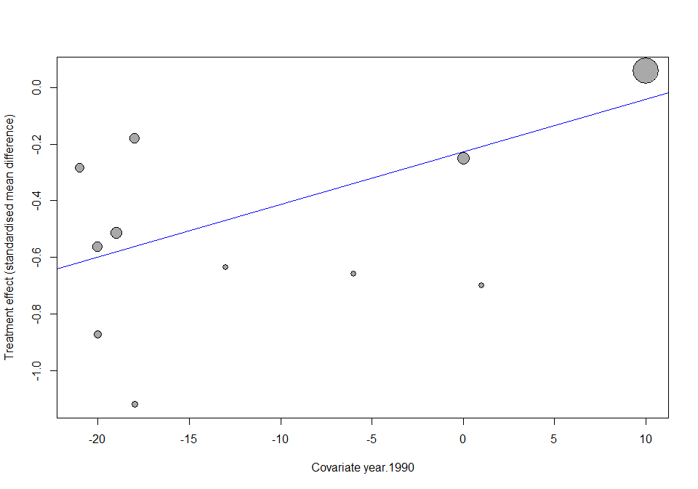

Did the treatment effect change over time? Especially, how do you interpret the meta-regression result after looking at the bubble plot?

Overall, we see a statistically significant influence of publication year on the treatment effect (p=0.0228). However, the bubble plot shows that this result is driven by the latest (and biggest) study which has a different treatment estimate than smaller studies.

## Indirect and mixed comparisons

## Triangular network dataset

Open the dataset PHOpairwise.xls by using the *Import Dataset* tab or type

PHOpairwise = read_excel("PHOpairwise.xls")  
PHOpairwise = as.data.frame(PHOpairwise)

This network includes studies from three comparisons; Olanzapine versus Haloperidol, Placebo versus Haloperidol and Placebo versus Olanzapine. The outcome is efficacy measured using a symptoms scale (mean, sd and ncont for arms 1 and 2). The lower the outcome, the better the efficacy of the treatment. The treatments for arms 1 and 2 can be seen in variables t1, t2. Some studies report endpoint values but most studies report change from baseline. Because studies might use different scales to measure the outcome, we will synthesize the data using the standardized mean difference (SMD). This is a very simple triangular network.

The aim of the first part of the practical is to fill-in the following table. The next commands will help you fill it in.

|  |  |  |  |  |  |
| --- | --- | --- | --- | --- | --- |
|  | **Direct evidence** | | | **Indirect evidence** | **Mixed evidence** |
|  | Haloperidol - Placebo | Olanzapine- Placebo | Haloperidol - Olanzapine | Haloperidol - Olanzapine | Haloperidol - Olanzapine |
| SMD | -0.581 | -0.439 | -0.149 | -0.142 | -0.146 |
| Var(SMD) | 0.0962 | 0.0612 | 0.0892 | 0.1142 | 0.0702 |
| 95%CI | [-0.770; -0.393] | [-0.560; -0.318] | [-0.322; 0.025] | [-0.366; 0.082] | [-0.283; -0.009] |
| Heterogeneity τ2 | 0.0311 | 0.0133 | 0 |  |  |
| Number of studies | 6 | 9 | 2 |  |  |

## Direct evidence from pairwise (subgroup) meta-analyses

Summarize the SMDs from studies grouped by comparison using metacont and the option 'byvar' for subgroups. Then fill in the respective columns of the table considering the results from the random-effects model using the default DerSimonian-Laird estimator.

pooledSMD = metacont(ncont1, mean1, sd1, ncont2, mean2, sd2,  
 data = PHOpairwise, studlab = author, sm = "SMD",   
 byvar = contrast, print.byvar = FALSE, comb.fixed = FALSE)  
summary(pooledSMD)

## Number of studies combined: k = 17  
##   
## SMD 95%-CI z p-value  
## Random effects model -0.45 [-0.56; -0.34] -8.05 < 0.0001  
##   
## Quantifying heterogeneity:  
## tau^2 = 0.0309; H = 1.60 [1.23; 2.08]; I^2 = 60.8% [33.4%; 76.9%]  
##   
## Test of heterogeneity:  
## Q d.f. p-value  
## 40.77 16 0.0006  
##   
## Results for subgroups (random effects model):  
## k SMD 95%-CI Q tau^2 I^2  
## Haloperidol - Olanzapine 2 -0.15 [-0.32; 0.03] 0.01 0 0.0%  
## Haloperidol - Placebo 6 -0.58 [-0.77; -0.39] 12.07 0.0311 58.6%  
## Olanzapine - Placebo 9 -0.44 [-0.56; -0.32] 13.28 0.0133 39.7%  
##   
## Test for subgroup differences (random effects model):  
## Q d.f. p-value  
## Between groups 11.99 2 0.0025  
##   
## Details on meta-analytical method:  
## - Inverse variance method  
## - DerSimonian-Laird estimator for tau^2  
## - Hedges' g (bias corrected standardised mean difference)

Consider your input in Table 1. Both drugs are better than Placebo, thus the SMDs should be (and are) negative.

Note, we can extract the direct treatment effect of the comparison of Haloperidol and Olanzapine and its standard error from R object pooledSMD:

directHO = pooledSMD$TE.random.w[pooledSMD$bylevs == "Haloperidol - Olanzapine"]  
se.directHO = pooledSMD$seTE.random.w[pooledSMD$bylevs == "Haloperidol - Olanzapine"]

We will need this information later to compare direct with indirect evidence for the comparison between Haloperidol and Olanzapine.

## Indirect comparison between Haloperidol and Olanzapine

How much does Haloperidol and how much does Olanzapine reduce the symptoms of acute mania?

Which of the two active drugs is better?

Can you derive an indirect SMD for the comparison Haloperidol versus Olanzapine? You can do so by subtracting the two SMDs from the comparisons with Placebo.

First, we extract the direct treatment effects of the comparisons of Haloperidol and Olanzapine with Placebo

directHP = pooledSMD$TE.random.w[pooledSMD$bylevs == "Haloperidol - Placebo"]  
directOP = pooledSMD$TE.random.w[pooledSMD$bylevs == "Olanzapine - Placebo"]

and the corresponding standard errors

se.directHP = pooledSMD$seTE.random.w[pooledSMD$bylevs == "Haloperidol - Placebo"]  
se.directOP = pooledSMD$seTE.random.w[pooledSMD$bylevs == "Olanzapine - Placebo"]

Then, we can calculate the indirect estimate

indirectHO = directHP - directOP

We can also estimate a standard error for the indirect SMD (as the variances of the direct estimates are independent and thus always add-up).

se.indirectHO = sqrt(se.directHP**2 + se.directOP**2)

We can use these quantities to estimate a 95% confidence interval for the indirect SMD:

metagen(indirectHO, se.indirectHO, sm = "SMD")

## SMD 95%-CI z p-value  
## -0.14 [-0.37; 0.08] -1.24 0.2136  
##   
## Details:  
## - Inverse variance method

Go and add this information into the Table (fourth column of results) - it is the SMD and 95% confidence interval of the indirect comparison Haloperidol - Olanzapine.

## Compare direct and indirect evidence

The heterogeneity is estimated to be zero, what do you think about this? Are you confident that there is no heterogeneity?

How does the direct summary SMD compares with indirect SMD? Are they in reasonable agreement?

Compare the 95% confidence intervals between direct and indirect evidence. What do you conclude?

Which evidence is more precise and why?

Note that these two pieces of evidence (direct and indirect) are independent because they have been estimated using different sets of studies; Placebo - Olanzapine and Placebo - Haloperidol studies for the indirect and Olanzapine - Haloperidol studies for the direct. Consequently, they can be pooled into a single summary SMD using a new, second-level meta-analysis to estimate a mixed treatment effect.

## Combine direct and indirect evidence into a mixed treatment effect

Create a dataset called DirectIndirect with two new studies; direct and indirect evidence about the comparison Haloperidol vs Olanzapine.

Use two variables named 'SMD' and 'seSMD' (with values those in the Table)

DirectIndirectHO = data.frame(source = c("indirect" , "direct"),   
 SMD = c(indirectHO , directHO),  
 seSMD = c(se.indirectHO, se.directHO))

These two SMDs can be meta-analyzed. The metagen function can take effect sizes and their standard errors as arguments. Meta-analysis of these two sources of evidence will produce a mixed SMD.

metagen(SMD, seSMD, data = DirectIndirectHO, studlab = source, comb.random = FALSE)

## 95%-CI %W(fixed)  
## indirect -0.14 [-0.37; 0.08] 37.5  
## direct -0.15 [-0.32; 0.03] 62.5  
##   
## Number of studies combined: k = 2  
##   
## 95%-CI z p-value  
## Fixed effect model -0.15 [-0.28; -0.01] -2.09 0.0369  
##   
## Quantifying heterogeneity:  
## tau^2 = 0; H = 1.00; I^2 = 0.0%  
##   
## Test of heterogeneity:  
## Q d.f. p-value  
## 0.00 1 0.9650  
##   
## Details on meta-analytical method:  
## - Inverse variance method

Now add the values of the mixed SMD and the 95% CI to complete the table.

## References

* Cipriani A et al. (2011): Comparative efficacy and acceptability of antimanic drugs in acute mania: a multiple-treatments meta-analysis. *The Lancet*, **378**(9799), 1306-15.
* Leucht S et al. (2013): Comparative efficacy and tolerability of 15 antipsychotic drugs in schizophrenia: a multiple-treatments meta-analysis. *The Lancet*, **382**(9896), 951-62.